**Exercise 1: Configuring a Basic Spring Application**

**Exercise 2: Implementing Dependency Injection**

BookRepository.java

package com.library.repository;

public class BookRepository {

public void saveBook(String bookName) {

System.***out***.println("Book '" + bookName + "' saved to database.");

}

}

BookService.java

package com.library.service;

import com.library.repository.BookRepository;

public class BookService {

private BookRepository bookRepository;

// Setter for Dependency Injection

public void setBookRepository(BookRepository bookRepository) {

this.bookRepository = bookRepository;

}

public void addBook(String bookName) {

System.***out***.println("Adding book: " + bookName);

bookRepository.saveBook(bookName);

}

}

LibraryManagementApplication.java

package com.klu.LibraryManagement;

import com.library.service.BookService;

import org.springframework.context.ApplicationContext;

import org.springframework.context.support.ClassPathXmlApplicationContext;

public class LibraryManagementApplication {

public static void main(String[] args) {

ApplicationContext context = new ClassPathXmlApplicationContext("applicationContext.xml");

BookService bookService = (BookService) context.getBean("bookService");

bookService.addBook("Java Programming");

}

}

applicationContext.xml

<?**xml** version=*"1.0"* encoding=*"UTF-8"*?>

<**beans** xmlns=*"http://www.springframework.org/schema/beans"*

xmlns:xsi=*"http://www.w3.org/2001/XMLSchema-instance"*

xsi:schemaLocation=*"*

*http://www.springframework.org/schema/beans*

*http://www.springframework.org/schema/beans/spring-beans.xsd"*>

<**bean** id=*"bookRepository"* class=*"com.library.repository.BookRepository"* />

<**bean** id=*"bookService"* class=*"com.library.service.BookService"*>

<**property** name=*"bookRepository"* ref=*"bookRepository"*/>

</**bean**>

</**beans**>

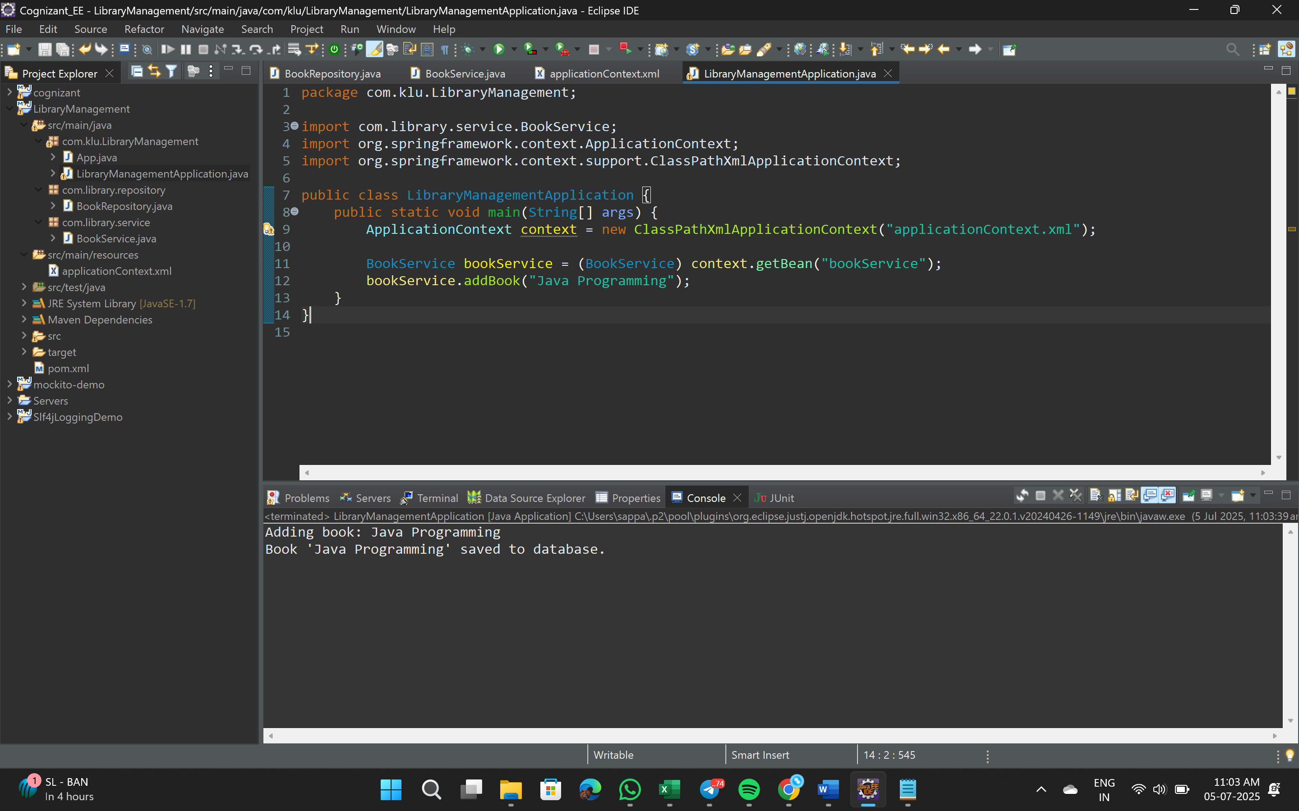

**Exercise 4: Creating and Configuring a Maven Project**

